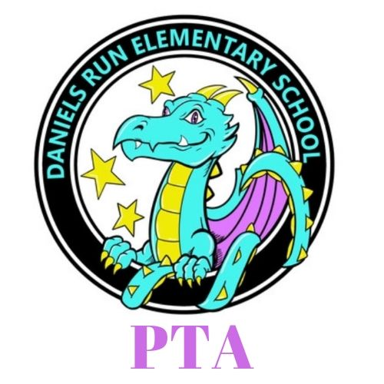

Daniels Run PTA

Meeting Agenda - January 16, 2025

I. Welcome and Introductions, called to order at 7:01 PM. 12 members present.

III. Admin Report - Ms. Mullen

Visit to Sunrise Assisted living community home, chorus singers visited in December.

Strings concert this week, over 100 students participate in the strings program.

Geometry is going on all around the school! As well as some assessments.

Potential event Music Movies Night, through the Honors Program at Fairfax High School.

IV. Reports of Officers

1. President- Beth Brixius
   1. International Night
   2. Bingo Night - February 28. A high energy night with lots of prizes and raffle baskets.
   3. Spring Cleaning - April 1, 9:30-11 morning.
   4. Donuts with Dragons, date not set yet
   5. Daniels Run vs. Providence game in spring
   6. BOGO book fair
   7. Teacher Appreciation Week. We need lots of volunteers.
   8. Nominating Committee - Need to fill within the next month.
2. VP Fundraising- Sara Pagani
3. VP Membership- Elli Davou
   1. Membership Update - 199 members currently.
4. Secretary- Alex Hume
   1. International Night - coming up February 20th. Concert is the 2nd hour, 1st hour is the table event. Ms. McCarten would love more parents and other volunteers for the performance.
5. Treasurer- Lauren McMinn
   1. Ice Skating Event - a fairly young event, 3 or 4 years, Daniels Run students will receive a ticket for skates and admission. Family members will pay their own admission. It’s on the CUE bus route too!
   2. Budget Report - no update on budget right now.

VII. Adjournment - Meeting adjourned at 7:30 PM.